Buying things in prison

Unit 2

Managing my money





Contents

Unit 2 Managing my money teachers’ notes

Unit 2 Managing my money learner resources

Unit 2 Managing my money additional resources

Unit 2 Managing my money - teacher’s notes
This unit introduces vocabulary related to money and budgeting in the context of earning, spending and saving whilst in prison. Functional numeracy and the ability to manage personal finance is considered an area of need for prisoners. One of the tasks asks learners to create a simple budget. Depending on your learners, you may need to think how difficult a task/concept this might be and what extra support or time you might need for this task.
Differentiation options are included and some extension activities also to help with multi-level classes.
If photocopying options are limited and a Smart Board is available, some items could be copied into a Smart Notebook file e,g, Resource 2a and 5 and learners can write answers on their own paper.
Time: 90 minutes
Level: Entry level 1-3 / Scottish National 2 – National 4 / CEFR A1 - B1
Aims:

- to equip learners with vocabulary to talk and understand conversations about money and become familiar with the notion of budgeting
- to learn language related to basic number skills.

Objectives
All learners will be able to:
- understand and use ten colloquial vocabulary items related to money and talk about their spending habits
- recognise why people budget and create their own simple budget
Most learners will be able to:
- use simple addition and subtraction skills

Some learners will be able to:
- prepare a three week budget.
- use ‘going to’ to talk about their future budgeting intentions. (extension).
Preparation
You will need:
Lead in: whiteboard, picture of a catalogue e.g. Argos, coin flashcards (cut up)
Activity 1: Resource 1, coin flashcards (cut up)
Activity 2: Resource 2a, Resource 2b Anna and Janusz
Activity 3: Resource 3, one dice per group of three/four
Activity 4: Resource 4 Budget one each or cut up for less proficient learners
Activity 5: Resource 5 (cut up, if learners can only manage one to create a one week budget)
Extension activity: Resource 6

Suggested Procedure
Lead in:

Discuss the questions below. They introduce the theme and help you determine to what extent learners can talk about money-related topics and concepts. Be aware that some learners might be sensitive about financial issues so don’t force people into sharing details.

Questions can be added, changed or omitted to suit your group and prison but keep the same theme of money. Take each question at a time. Write it on the board to give visual support, where learners are generally able to read. Learners can work in pairs or threes to answer, which will maximise their talking time. Get some feedback from the class as a whole at the end and discuss any issues which arise.

- How do you get your money?
(Elicit key areas such as attending education or working to check learners have understood the question.)
- What do you usually buy on the canteen?
(Show the canteen sheet if any learners are new and unfamiliar with the term)
- Do you buy things from a catalogue sometimes?
(Show a picture of the type of catalogue which might be used in your prison e.g. Argos or Avon.)
- Do you spend all your money every week?
(Use some coin flashcards to show the idea of spending money when you buy something.)
- Do you save money?
(Use coin flashcards again to show the idea of saving as opposed to spending.)

Activity 1: Vocabulary input – ten phrases

- Ask learners to read the text on resource 1 and answer the gist questions in pairs. Then ask them to feed back their answers.
- Ask learners to look at the words in bold in the text and in pairs discuss briefly if they know what any of them mean.
- Take brief feedback but then direct learners to activity 1b. Learners have to choose the correct meaning of the word or phrase. Do the first one together as an example. Learners can use a dictionary if they have one but encouraging them to guess from the context will develop their reading skills.
- Elicit from the learners which words they think can be only used in informal situations because they are slang (quid, skint) and correct or confirm the answers.

Differentiation:

- Activity 1a: For learners with weaker reading skills, read the text aloud with learners following and deal with the new vocabulary sentence by sentence, pausing to check understanding, then read it through again as a whole text at the end.
- Activity 1b: This could be done as a whole class quiz by reading each vocabulary item and the definitions. Ask teams to choose which of the definitions they think is correct.

Activity 2: Vocabulary practice

- Look at the pictures and information on resource 2a. Elicit what the pictures show. Point to Anna. Say ‘this is Anna’. Ask ‘How much money does Anna have?’ and point to ‘I have £0’. Point to the toothpaste and ask ‘Does Anna have toothpaste?’ Elicit that the cross indicates that Anna has ‘run out of’ toothpaste and so on. Answer key: Anna = no money / no toothpaste / can’t buy coffee / bits and pieces for her hair / coffee is expensive.
- In pairs learners ask each other similar questions about Janusz. He has five pounds / is not spending money / toothpaste is cheap / enough money to buy coffee / has no coffee.
- Learners change partners and take it in turns to read the speech bubbles on resource 2b and decide who said what and write the name Anna or Janusz at the bottom of the speech bubble. Do the first one together as a model.

Differentiation:

- Give the key vocabulary from 1b to lower level learners.
- While the more advanced learners work in pairs, you could read out the speech bubbles and ask lower level learners in turn to guess who said what, pointing to the relevant images if necessary.

Activity 3: Oral vocabulary practice game

This activity aims to develop oral fluency and expression and at the same time help learners become more familiar with the vocabulary from the text.

- Look at resource 3. Learners work in threes or fours, with a grid and a dice. Read all the questions together as a group first and deal with any that are not understood.
- The first learner rolls the dice and answers the question which corresponds to the number on the dice. He passes the dice to the next person who does the same and this continues around the group. Learners don’t need to answer the same question twice they can pass the dice on.
- You can give this activity a time limit e.g. 5- 10 minutes
- Or it can also be done as a competition, which will take longer and there may not be time for other aspects of the lesson in the same session. See the instructions below:

- The game is competitive and the winner is the first player to have answered all 6 questions shown on the grid correctly.
- The first player rolls the dice and answers the question that corresponds with the number on the dice.
- When a learner answers the question correctly, he writes his initials in square #5. If he rolls #5 again later in the game, he has to miss his go. Players can only answer each question once.
- The dice then passes to the next player who rolls it and answers the questions corresponding to the number he has rolled. He then puts his initial in the box and gives the dice to the next player.
- The game continues until one player has their initials in all the boxes, which makes him the winner.

This game is best done in groups of three or four. You may need to model the game first to introduce the concept, if learners have difficulty following what to do from oral instructions. If it is done as a game, be aware that groups will finish at different times, so you may want to give an overall time limit or have another activity for early finishers.

Differentiation:

- If some learners struggle to read the questions, put them in a group with stronger readers to help them, if possible.
- If many of the group are weak readers, make this a whole group activity. One learner rolls the dice and you read the question to that learner; they answer and then the dice passes to the next learner.
- Alternatively, in a large class, split the learners into two groups. Someone in each group rolls the dice and you go between the two groups, reading each question aloud for all learners in the group to answer.

Activity 4: Learning about budgeting

- Show the learners resource 4, the budget sheet example, and talk about what it is, how it works and why Mehmet is making a budget. Try and elicit their own prior experience using closed and open questions to generate discussion and cater for different ability levels.
- In activity 4b learners have to add up the outgoings on the budget and subtract it from the total monthly amount, leaving the amount he can still spend.
- Depending on your group, this task can be done as a whole group on the board, if learners are very weak at maths; in pairs, or one pair or group could each add up one of the weeks.
- Elicit and correct answers.
- Ask some general questions about Mehmet’s spending e.g. How much money does he spend on socks? How much does he have at the end of week 2?
- In activity 4c learners need to try and make their own budget using a model canteen sheet to help with the process, if necessary. Use resource 5 as the budget template.
- Depending on your group, learners can work individually or in pairs to complete this or, if they need more guidance, the class could choose one student as an example and the budget could be completed as a whole class on the board first.

Differentiation:

- The budget sheet could be cut up into three separate parts, one for each week. Everyone could be given one part for the next week. Some may only complete one week. For those who can do more, hand them a new weekly sheet when they are ready.

Cooler:

- True/false quiz. Look at resource 2 again. Ask true/false questions about Janusz and Anna using the key vocabulary items from the lesson. e.g. Janusz is skint. Anna has run out of toothpaste.
- Learners can share with the whole group things they are going to buy and save for in the coming months.

Extension activities: ‘Going to’ for future intentions

- Using resource 6, look at Mehmet’s speech bubbles and establish that using ‘going to’ is the way of talking about something you have decided to do in the future. Fill in part b) on the resource.
- Ask learners to look at their budget and elicit some of the things they are intending to buy and save for in the coming months. Write their suggestions on the board if they are happy to share. Deal with any grammar issues arising.
- Allow learners to write their own speech bubbles on the resource part c. Monitor, check answers and deal with any further issues.
- Learners can then talk in small groups about their budgeting plans using the language from part c. Feed back as a whole class at the end.

Unit 2: Managing my money. Learner resources.
Resource 1
1. a) Read the text and find the answers to these questions.
- What does Mehmet normally buy from the canteen sheet?
- What did he buy last month?
- How much did he save every week?
‘It’s really tricky with money here in prison. About seven quid a week is all I get – I’m skint by the end of the month. I can’t afford to buy a lot of stuff. At the beginning I spent lots of money on food – but now I normally buy some food and other bits and pieces I need, like a pen, paper or a birthday card. I sometimes save up and try to buy some bigger things. Last month I saved up and bought myself a jar of coffee. I saved one pound every week and then I could afford it. Some things are pricey but others are quite reasonable. It’s different from before. I have to be really careful with my money now and plan a bit - think about what I need to buy and when because I don’t want to run out of stuff like deodorant or toothpaste.’ Mehmet

1. b) Look at the words in bold from the text and tick the correct meaning.

1. tricky | a. easy | b. difficult
2. quid | a. pounds | b. pence
3. skint | a. to have lots of money | b. to have no money
4. I can’t afford to buy | a. I can’t buy it because I have no money | b. I have money and I can buy it
5. bits and pieces | a. pen and paper | b. things
6. save up | a. spend a bit of money each month | b. save a bit of money each month
7. I could afford it | a. I couldn’t buy it because I had no money | b. I had money and I could buy it
8. pricey | a. expensive | b. cheap
9. reasonable | a. a good price | b. expensive
10. run out of stuff | a. have no stuff left | b. have lots of stuff
Resource 2a Activity 2 Ann and Janusz talk about their money and buying things. Look at what they say on Resource 2 b and write the correct name on the speech bubble.

I …………….    Anna  £0 | 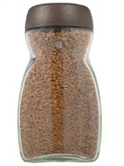 | 
 | 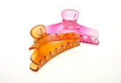
 | coffee £3  I have £0 | £££
I ………………

  Janusz | 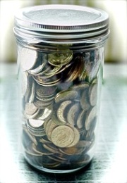 | 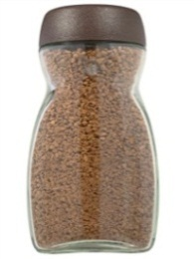
£5 | coffee £3  I have £5 |  £

Resource 2b Activity 2 Who says what? Write Anna or Janusz’s name in the correct speech bubble
3. I’m skint.
4. Coffee is pricey.
2. I have run out of toothpaste.
1. I can afford some coffee.
10. I’ve got five quid.
9. I want to buy some bits and pieces for my hair.
7. Toothpaste is a reasonable price.
5. I am saving up.
8. I can’t afford any coffee.
6. I have run out of coffee.
1.  Is it tricky with money in prison?  Why? | 2.  Are you  sometimes skint? | 3.  What bits and pieces do you normally buy each month?
4.  Do you save up for things?  What? | 5.  Can you afford to buy things you need each month?  If so, what? | 6.  Name two pricy things on the canteen list.
Resource 3. Dice game grid
Resource 4. My budget
4. a) In September Mehmet makes a plan for his money each week called a budget. Why does he do this?
b) Add up how much he is going to spend, how much he is going to save for his son’s birthday present and find out what he will have left .

What I need: Week 1 |  |  | What I need: Week 2 |  |  | What I need: Week 3
socks  apples  deodorant  tissues |  | £1.50  0.99  0.80  0.75 | washing powder  breakfast cereal  sugar  biscuits |  | £1.00  £2.35  £1.10  0.50 | toothpaste  batteries  shampoo  birthday card |  | 0.82  £3.30  £1.20  0.65
Money saved for  birthday present |  | +£1.00 | Money saved for  birthday present |  | +£1.00 | Money saved for birthday present |  | +£1.00
Total |  | a) | Total |  | b) | Total |  | c)
Total | £7.00 – a)  d) = |  | Total | £7.00 – b)  e) = |  | Total | £7.00 – c)  f) =

c) Extension: Make your own budget for the next three weeks.

Resource 5. My budget
What I need: Week 1 |  |  | What I need: Week 2 |  |  | What I need: Week 3
Money to save for  .......................................... |  |  | Money to save for  ....................................... |  |  | Money to save for  .........................................
Total |  |  | Total |  |  | Total
Total | £  = |  | Total | £  = |  | Total | £  =

Resource 6. Extension activity
b) I’m going to get some washing powder.
c) I’m going to get a birthday card for my son.
a) I’m going to buy some toiletries and apples next week.

e) I’m going get some batteries.
d) I’m going to save for a present for my son.

b) What words does Mehmet use to talk about what he plans to do in the future?
a............................................b........................................c.....................................

c) What are you planning to buy or save in the next few weeks? Finish the sentences with your own words.
b) I’m going to save for ..............................................................................
c) I’m going to get .........................................................................................................................................
a) I’m going to buy..............................................................................................................................

e) ....................................................................................
d) I’m ........................................................................................................................................

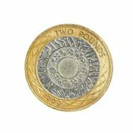 | 
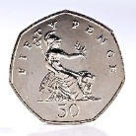 | 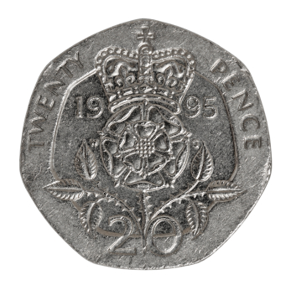
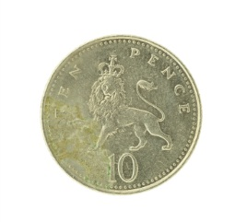 | 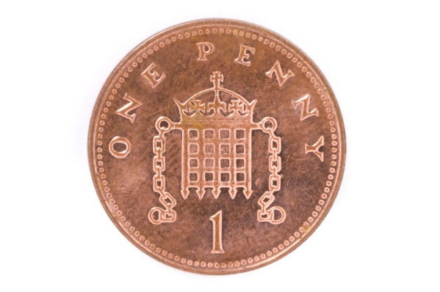
Teacher resources: Coin flashcards

Answers
Activity 1b / Resource 1
1a 2a 3b 4a 5b 6b 7b 8a 9a 10a

Activity 2a / Resource 2
1. Janusz  2. Anna  3. Anna  4. Anna  5. Janusz | 6. Janusz  7. Janusz  8. Anna  9. Anna  10. Janusz

Activity 4b / Resource 4
a. £5.04
b. £5.95
c. £6.97
d. £1.96
e. £1.05
f. 0.03 or 3p

Extension activity b / Resource 6
In any order:
- I’m going to buy
- I’m going to save
- I’m going to get

